Real-Time Bridge Monitoring

Design Description

Version 1.7

Revision History

Date | Version | Description | Author
2013-10-31 | 0.1 | Initial Draft | Jörn Tillmanns
2013-11-04 | 1.0 | First version of Design | Andrea Bottoli, Lorenzo Pagliari, Marko Brčić, Ghazal Shojaee, Jörn Tillmanns
2013-11-17 | 1.1 | Fixed Introduction  Fixed 2.1 Section  Fixed some formats | Andrea Bottoli, Lorenzo Pagliari
2013-11-18 | 1.2 | Fixed Sections 2.2, 2.3  Fixed Chapter 3 | Andrea Bottoli
2013-11-19 | 1.3 | Fixed User Interfaces Section | Andrea Bottoli
2013-12-03 | 1.4 | Added Class Diagrams | Andrea Bottoli
2013-12-04 | 1.5 | Added References to on-line Documentation  Added mockups in user interfaces chapter  Added some comments on the mockups and views | Andrea Bottoli
2014-01-07 | 1.6 | Text format and minimal fixes | Andrea Bottoli
2014-01-08 | 1.7 | Updated class diagrams and user interfaces | Marko Brcic
2014-01-13 | 1.8 | Updated database chapter | Jörn Tillmanns

Table of Contents
1. Introduction 4
1.1 Purpose of this document 4
1.2 Intended Audience 4
1.3 Scope 4
1.4 Definitions and acronyms 4
1.5 References 5
2. Software Architecture 6
2.1 Conceptual design 6
2.2 System specification 8
2.3 External Components 8
3. External interfaces 9
3.1 Hardware Interfaces 9
3.2 User Interfaces 9
4. Detailed software design 21
4.1 Implementation modules / components 21
4.2 Class Diagrams 23
4.3 Data flow / Interactions / Dependencies 26
4.4 Data Types / Formats 30
4.5 Database Model 31
4.6 Web site organization 35

Introduction
Real-Time Bridge Monitoring is a project for the Distributed Software Development course held by Politecnico di Milano, Malardalen University and University of Zagreb.

Purpose of this document
The purpose of this document is to assist in the development of the project 'Real-Time Bridge Monitoring”, as a part of the Distributed Software Development course. This document specifies the entire architecture and design of the “RTBM”-Software. These design decisions directly relate to the requirements, use-cases, attributes and interfaces of the system, as they are mentioned in the Software Requirements Specification document.

Intended Audience
This document is written mainly for the development team. It will assist the team during the development-phase and will be updated, if any design-decision will be changed.
It'll be shown the software architecture

Scope
The scope of this document it to present the overall architecture, then go into the details of each model, interface, technology that we used and other architectural aspects needed.
This document aims to present much detail as possible with the software architecture of the entire system, including the database, the parser, the math engine and the web application; there are also specified in detail the external interfaces, on the one hand towards the 'end-user and the other to the hardware components.
You will then be presented in detail on the model chosen for implementation, including sequence and class diagrams, data flow, types and formats of data, the database model, including its tables and, finally, the organization of the website.

Definitions and acronyms

Definitions
Keyword | Definitions
Real-Time Bridge Monitoring | Project Title
Web App | The web application of the project

Acronyms and abbreviations
Acronym or  abbreviation | Definitions
HTTP | Hyper Text Transfer Protocol
HTTPS | Hyper Text Transfer Protocol Secure
HTML | HyperText Markup Language
GUI | Graphical User Interface
AJAX | Asynchronous Javascript And XML
JSON | JavaScript Object Notation
MVC | Model View Controller
DB | Database
RTBM | Real-Time Bridge Monitoring

References
The main reference to this project is:
www.fer.unizg.hr/rasip/dsd/projects/real-time_bridge_monitoring
Other useful references:
- Project Plan:
  - http://www.fer.unizg.hr/_download/repository/Project_Plan_v1.1.pdf
- Design Document:
  - http://www.fer.unizg.hr/_download/repository/Design_Description_v1.0.pdf
  - http://www.fer.unizg.hr/_download/repository/Design_Description_v1.1%5B1%5D.pdf
  - http://www.fer.unizg.hr/_download/repository/Design_Description_v1.2.pdf
  - http://www.fer.unizg.hr/_download/repository/Design_Description_v1.3.pdf
  - http://www.fer.unizg.hr/_download/repository/Design_Description_v1.4.pdf
- Requirements Document:
  - http://www.fer.unizg.hr/_download/repository/Requirements_Definitionv0.01.pdf
  - http://www.fer.unizg.hr/_download/repository/Requirements_Definition_v1.1%5B1%5D.pdf
  - http://www.fer.unizg.hr/_download/repository/Requirements_Definition_v1.2.pdf
- Technical Annex for Inputs file, Conversions and Calculations
  - http://www.fer.unizg.hr/_download/repository/Inputs_Conversion___Formulas_Calculation.pdf

Software Architecture

Conceptual design
The system will be developed following the MVC pattern and will have some modules that will interfaces with each others to gather, elaborate, validate and present them data to the end-user.
The dsd.dao component will provide a unique access to the data for the system, that could call it to retrieve the data.
The dsd.view will present to the final user the data concerned the system, the sensors and other stuffs needed to manage the real-time situation of the bridge.
The dsd.model will present to the other components the high level model of the data in the Database, like raw data, parameters, users, etc.
The dsd.calculation is the math engine of the system, and it calculate all the formulas for retrieving the safety factor of the bridge; plus, it fills some more aggregate data fields in the database according to the formulas and the structural calculations done.
The dsd.controller is the “logic” of the system, that controls the input by the user, manage the callings done by the subsystems and so on.

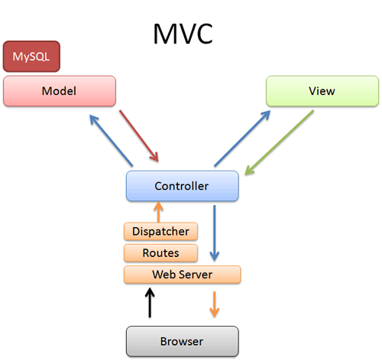
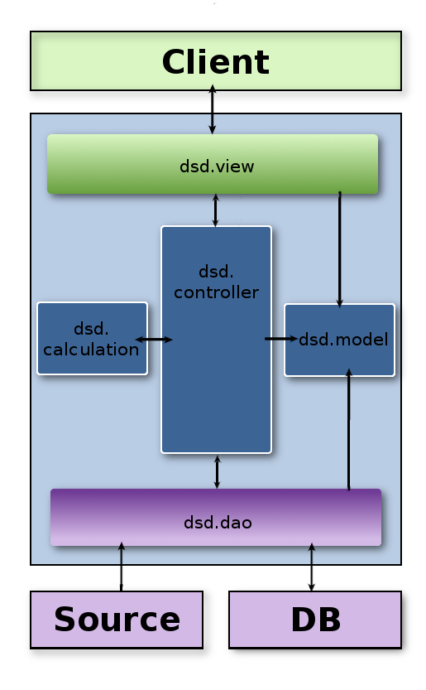

Source
It represent the input files that come from the sensors; they are two .jpeg files (picture taken from the camera on the bridge) and two .txt files (in which we can retrieve the timestamps and the data of the sensors).

Database
As Database we will use MySQL; it will, except of the media-data like photos and videos, contain all necessary data of the software. These data are:
- the raw-data from the sensors
- the pre-calculated sensor and danger-level data
- user-data
- parameters
- technical instruments

dsd.dao
It is a layer between logic which is the upper level and storage which is the down side which is directly connected to source and db layer. This inherits from source and DB interfaces.

dsd.calculation
The data from the sensors are delivered as raw text-files; these txt files have one data per second for each sensor on the bridge (one Hydrometer, one Ecosounder and one Sonar) and they have to be parsed and written into the database (the local server on the bridge, which is not under out control, sends one package per hour that contains two txt files and two jpeg files, so we will have 3600 single data for each sensor).
During this process the script will detect and compensate inconsistent data; this script will be automatically running in certain intervals. We have also to archive images from two cameras and create a sort of movie from the daily, weekly and monthly pictures.
The script will be divided into four submodules:
- The parsing-submodule will parse the data-files
- The image-submodule will recognize the new images
- The consistence-check will validate the read data and patch inconsistency (by the way, some other checkes will be done later in the system)
- The SQL-submodule will write all data into the database
- The film-submodule will create overview-movie for every day, week and month.
This component requires access to the data-files and the database.
The “calculation library” is the main-part of the software; it permits to the calculation engine to perform the structural calculations providing the formulas needed.
It will provide also the formulas to perform the calculations of the danger-level and other additional parameters based on the raw-data from the database.
The calculations will be performed in certain time-intervals and the calculated results will be stored in the database.

dsd.controller
This module controls the flow of data coming from the end-user, from the calculation library, from the data sources and from the database; it is the “logic” of the system and controls the correct behavior of the product.
Moreover it checks some validation of user input for instance log in.

dsd.view
The web service will present all data to the user and it is the only way how the user interact with the system.
To use the web service the user will use a common browser, the web service give him the possibility to log in and see information based on his access level.
Also for high access level there is the possibility to do some extra actions, as add or remove some users, give or remove access level, change parameters of calculation engine and so on. We will use a MVC pattern to develop the web service.

System specification
We use a Linux Debian 6.0 to build the server. To client side, the access to the web service can do by using each common browser as Google Chrome, Mozilla Firefox, Safari, Internet Explorer, Opera.
To programming we will use at server side Java for the calculation engine and the parser, and client side we will use html/css with JavaScript.

External Components
For the server we will use Apache with Tomcat for publish the web service, a daemon created by us as job scheduler to schedule the parser and calculation operations and MySQL to build the database.
On client-side we will use a simple and generic browser for display graphs.

External interfaces

Hardware Interfaces
The system gathers values from the following sensors and cameras:
- Anemometer: to measure wind speed and direction
- Hydrometer: to measure the water height
- Echo sonar: to measure the height of the bottom of the river and its changes
- Camera: two camera that periodically take a photo of the bridge
This hardware part is out of our control and we can't manage directly the sensors, the camera and also the way which the data is gather and send to the system; thus, we assume that we receive one package per hour composed by two txt files with raw sensor data, and two picture of the bridge taken by the camera.

User Interfaces

Administrator View

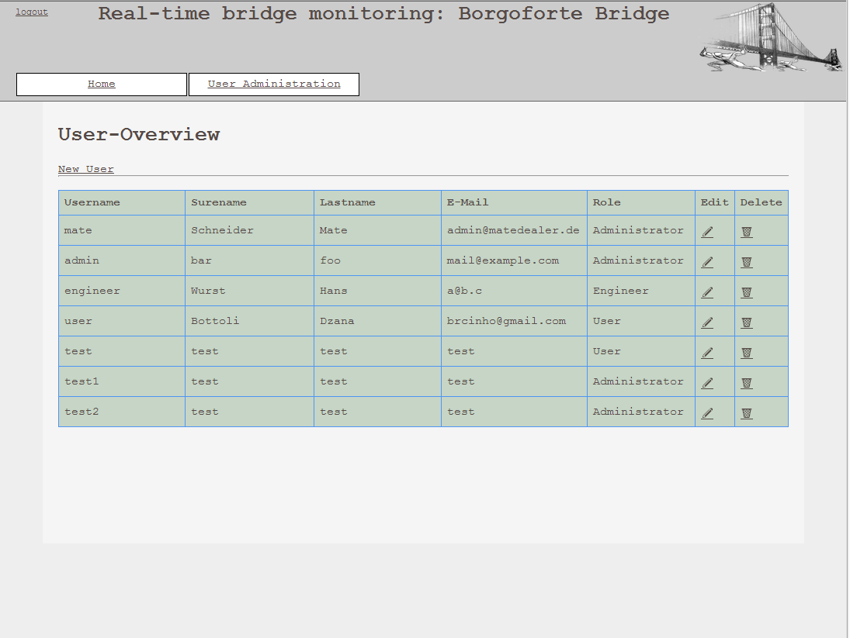
The administrator could see the user list, edit their attributes and delete them; plus, he could also add new users to permit them to interact (with the right privilege) with the system.

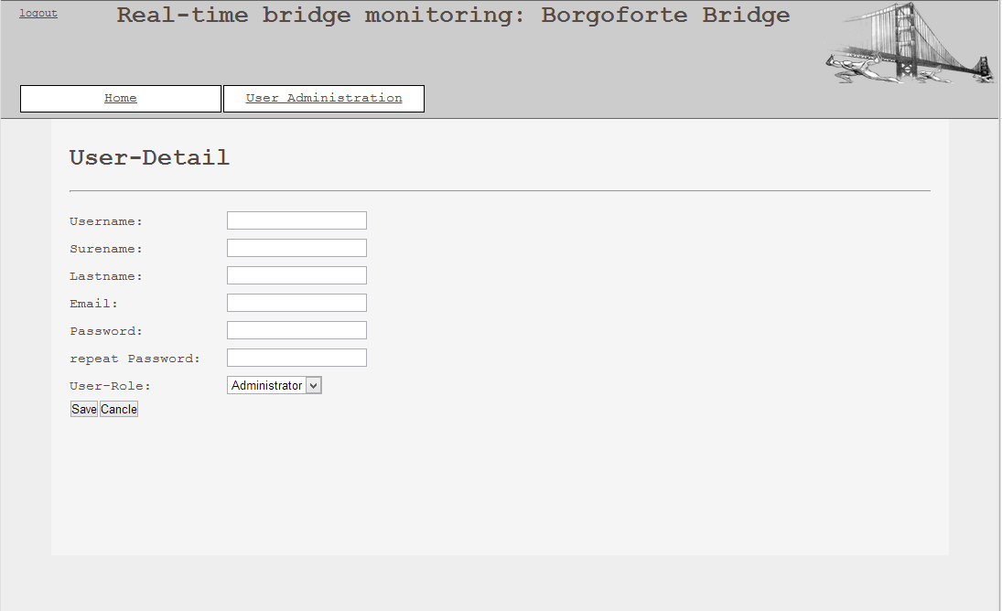

External User View

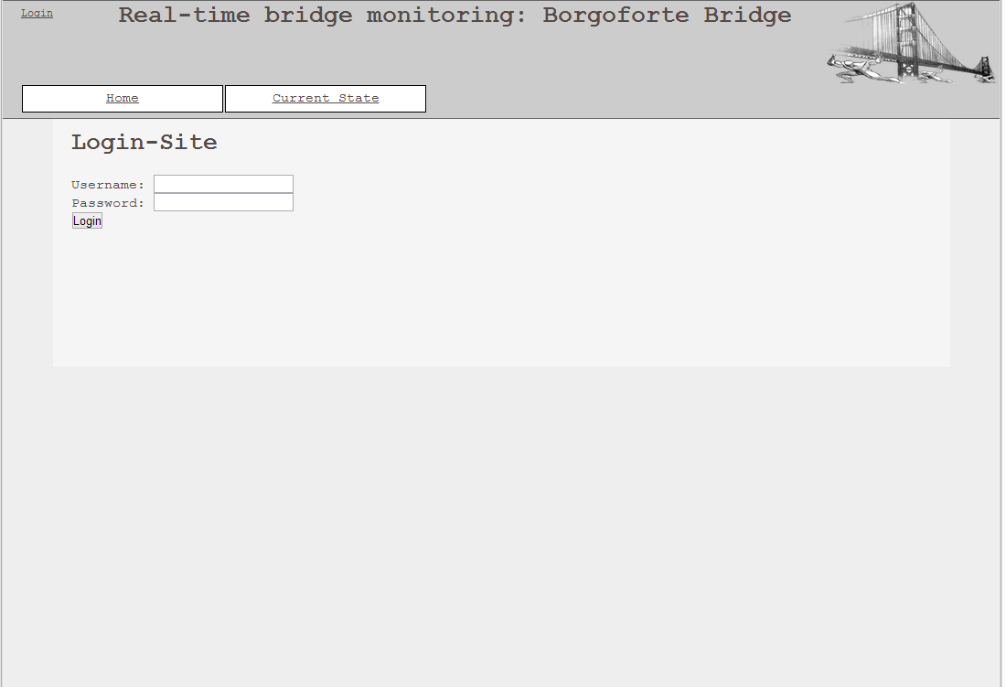
- Login page

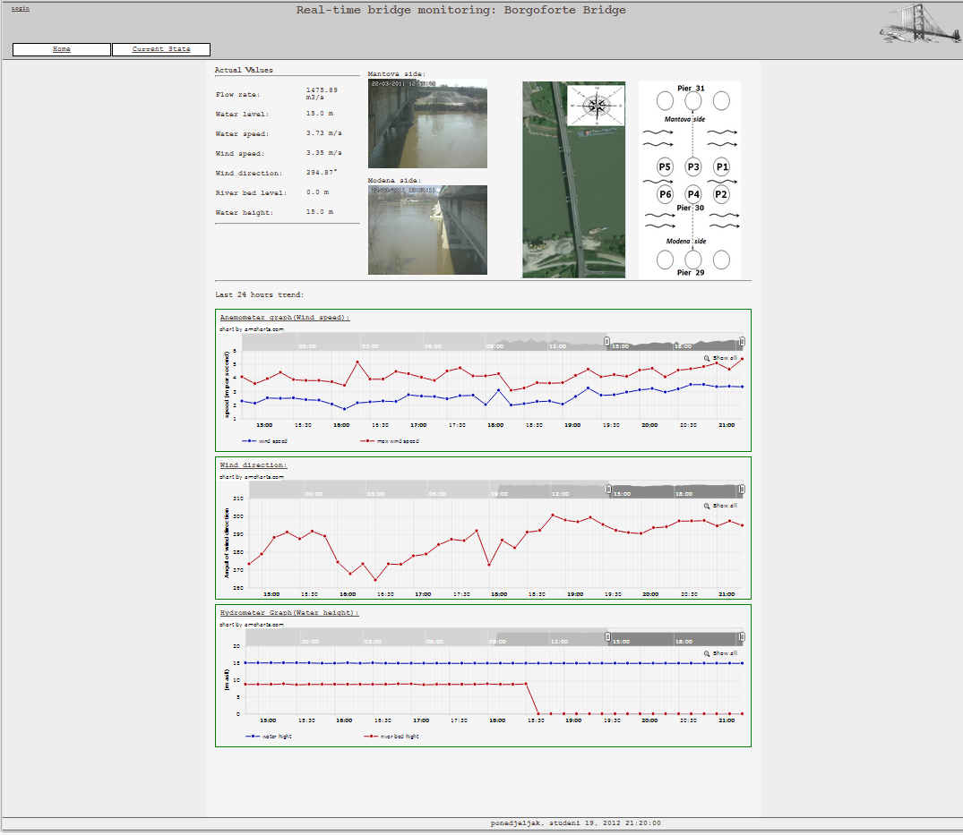
- Current State View

The External User could access the site without registration; obviously he could not see sensible data or graphs, and could not modify anything.
He could see the current graphs about the wind speed, the wind direction and the water and river bed level; plus, he could also see the current pictures of the bridge and some images that could be useful to understand better the position of the bridge and its structure.
He could not see the historical graphs and data.

- Home page
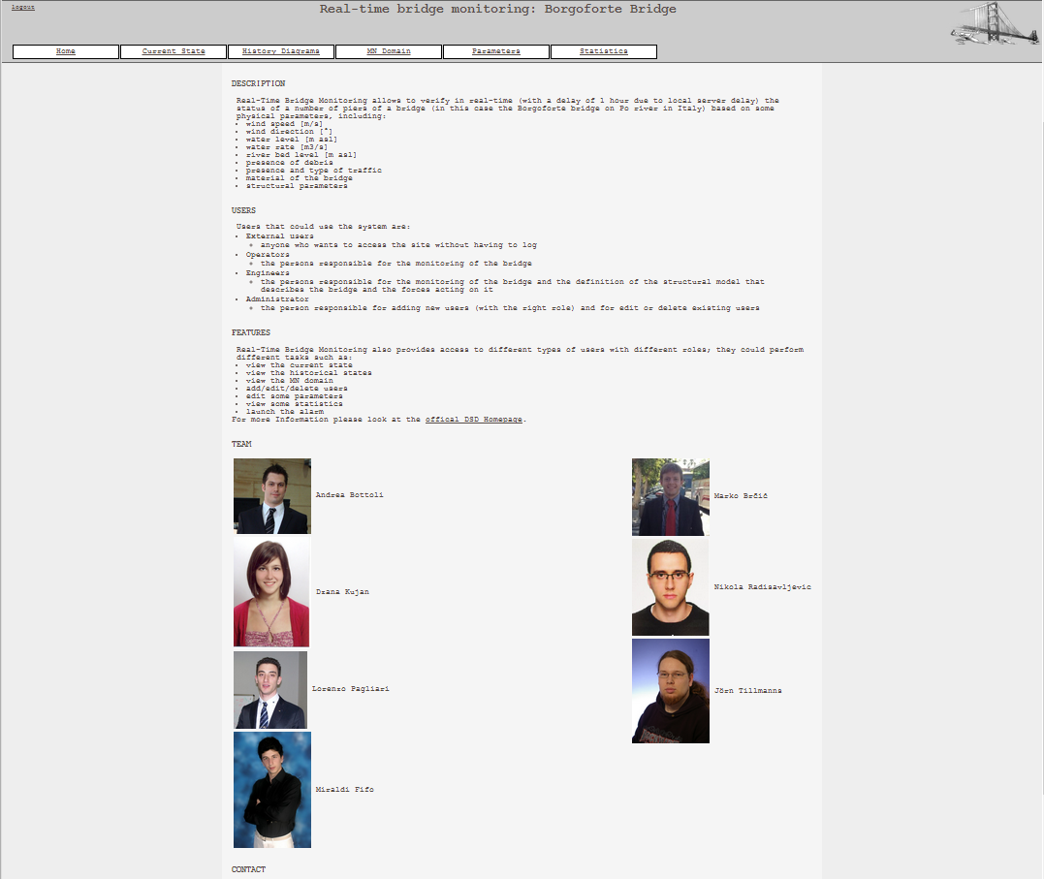

Home page is visible also with a short description of the project, description of type of users and features. All the team members and their pictures are also visible, with the contact information and the licence of the product.

Operator View
- Current State View
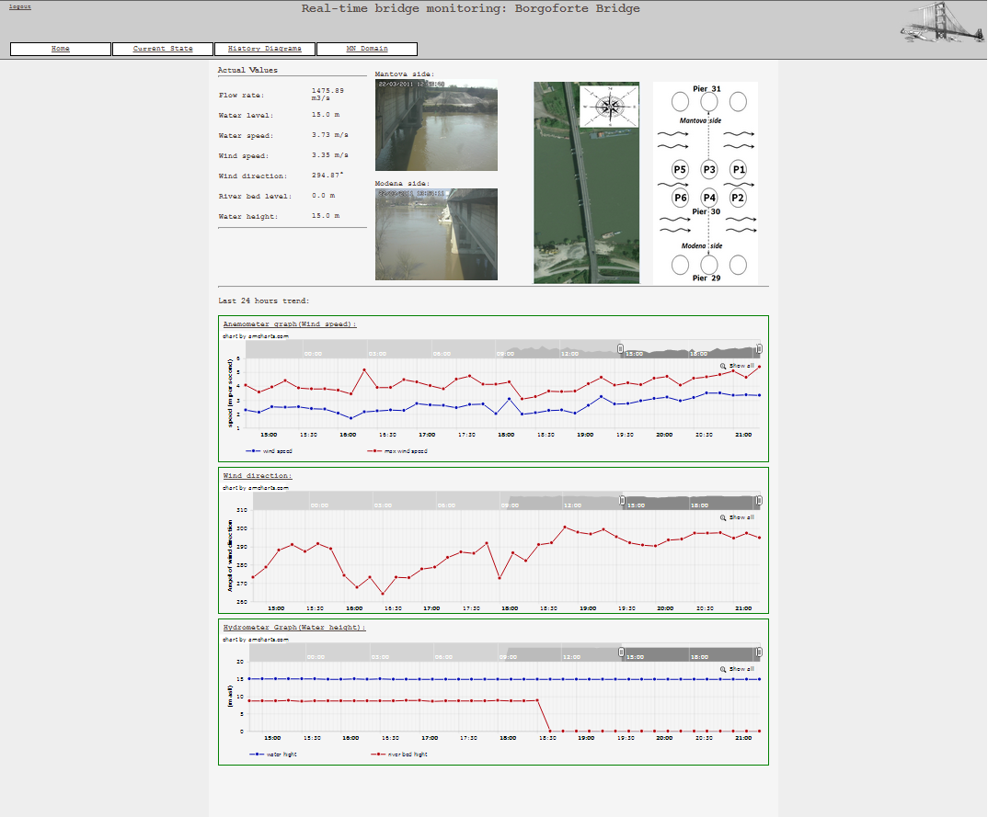
The operator could see the current status of the bridge, like the external user, plus the status of each pylon respect the critical domain M-N and some useful values about the forces that are working on the pylon.
He could also view four different scenarios, based on if there are Debris, Traffic, both of them or nor Debris or Traffic.
If he notice that one ore more pylons are in a critical situation, he could push the alarm button and notify to the person in charge to manage the emergency what is happening.

- Historical Graphs View
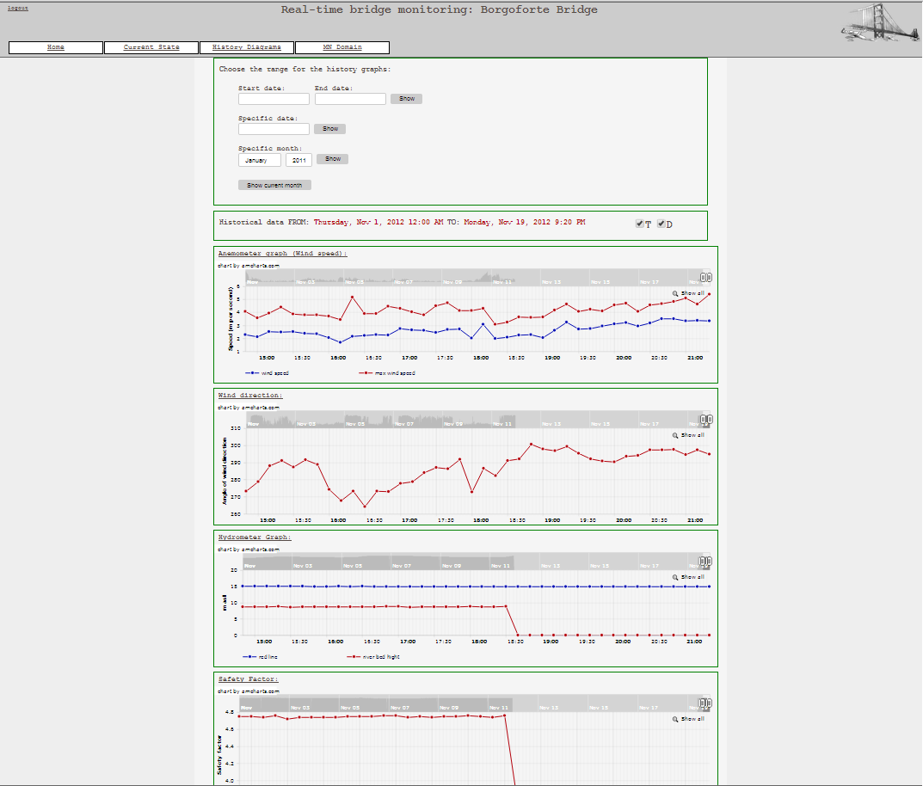
The operator could see the historical graphs he prefer; he can see the graphs related to the water and river bed level above the sea level, the wind speed and the wind direction, and also the Safety Factor (CS – Coefficiente di Sicurezza) trend.
He can choose to see graphs related to:
- a customized time-interval
- the last month (until the last update)
- a specific month
- a specific day

- MN domain
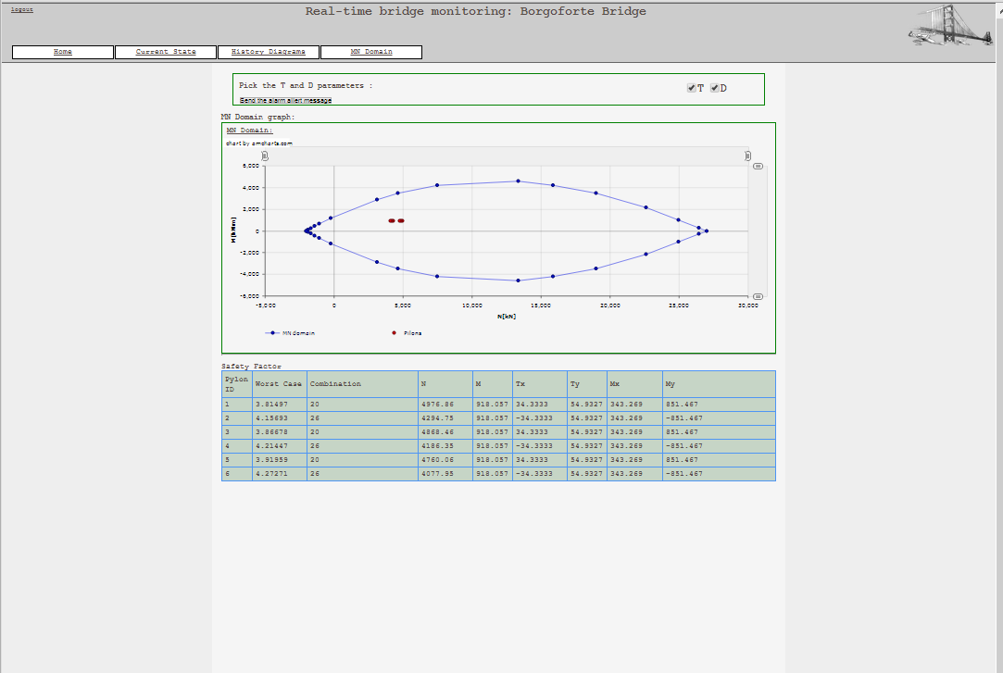
There is also the view of mn-domain.

Engineer View
- Current State View
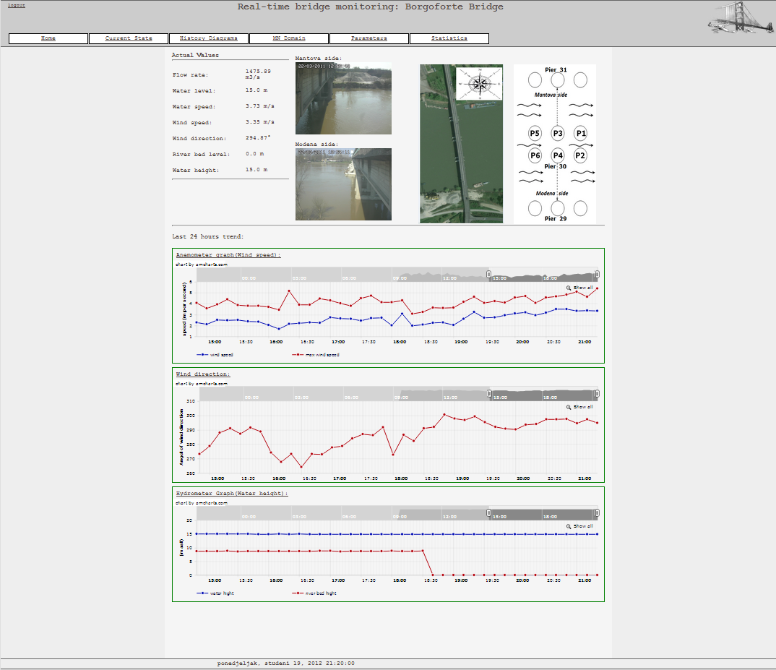
The engineer could see the same current status and could do also the same things of the operator; in fact, he is also an operator.

- Historical Graphs View
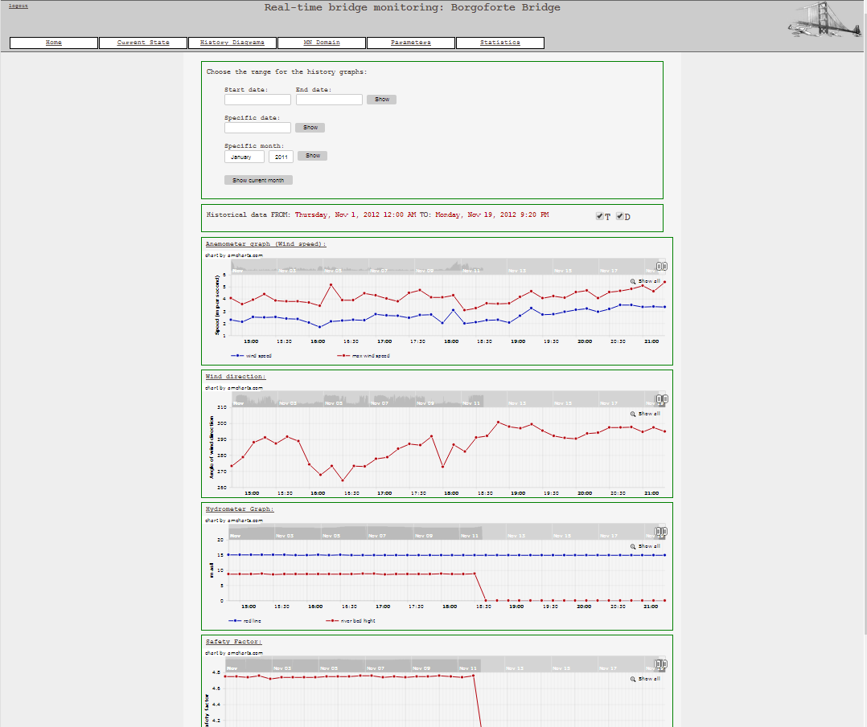
The engineer could see the same historical graphs of the operator and could choose the same options; in fact, he is also an operator.

- MN domain
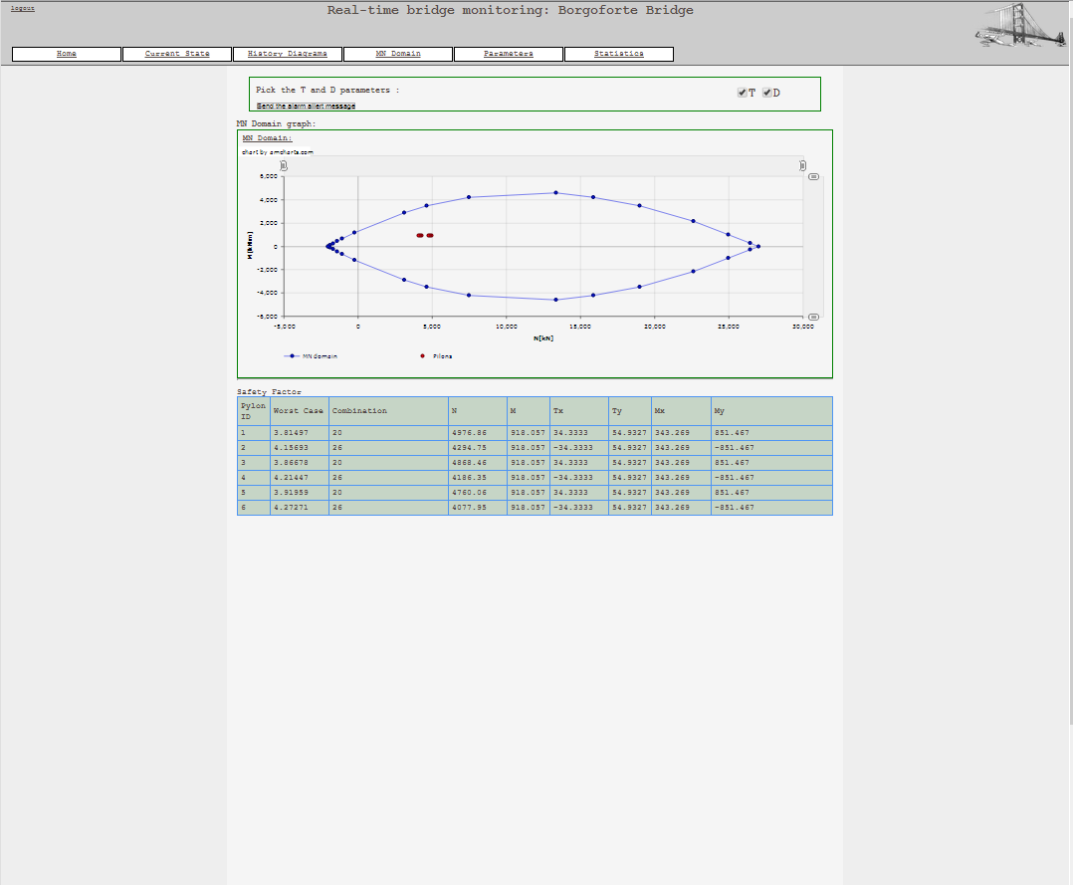
There is also the view of mn-domain.

- Parameters View
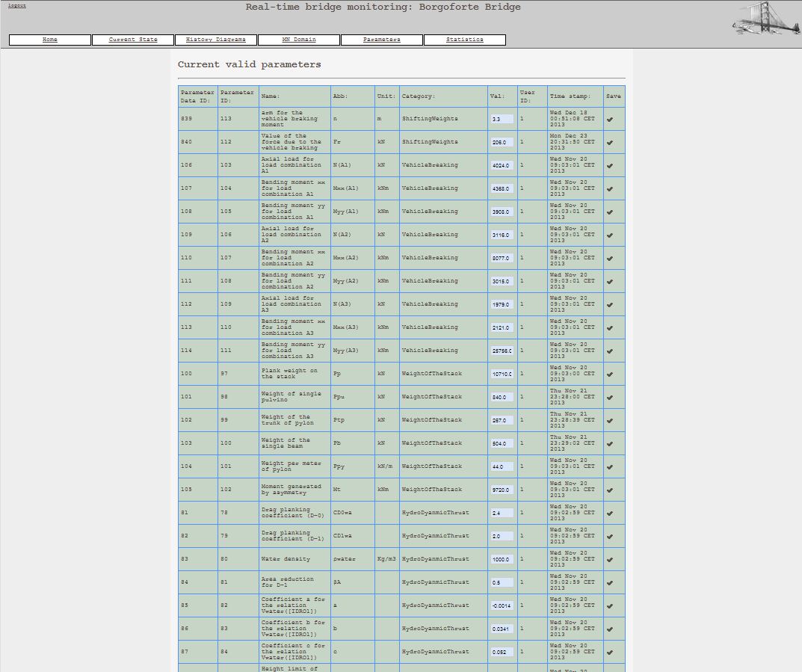
The engineer has a very difficult role and a very important responsibility for this system: he could modify all the parameters used to calculate the forces and to build the mathematical model of the structure of the bridge.
Thus, if he changes the model in a wrong way, the model, the calculations and so the safety factor will changes in a wrong way; so, he has to pay a lot of attention in change this parameters.

- Statistics View
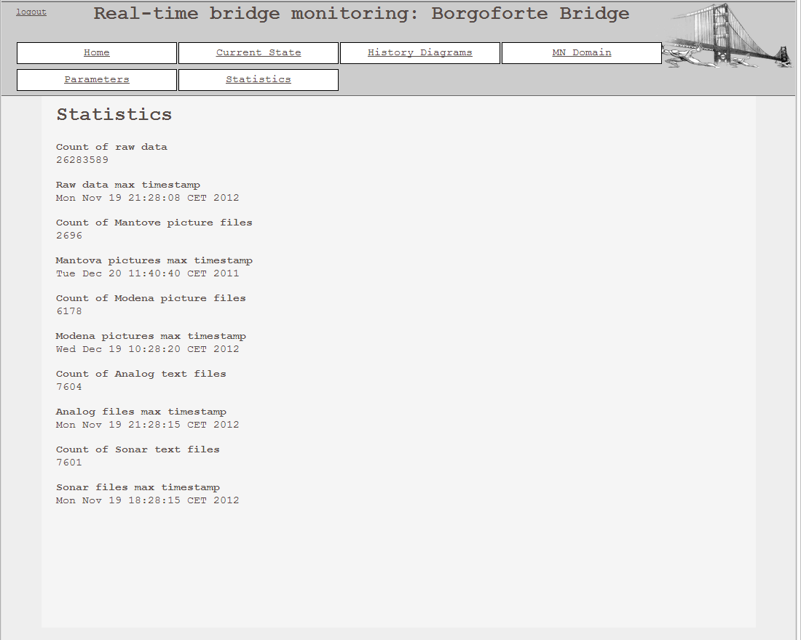
The engineer has also the possibility to look at the number and last parsed data for different types of data in the system. He can see those data for parsed files, analog, sonar, mantova and modena pictures and also for raw data.

Detailed software design

Implementation modules / components

Structured view
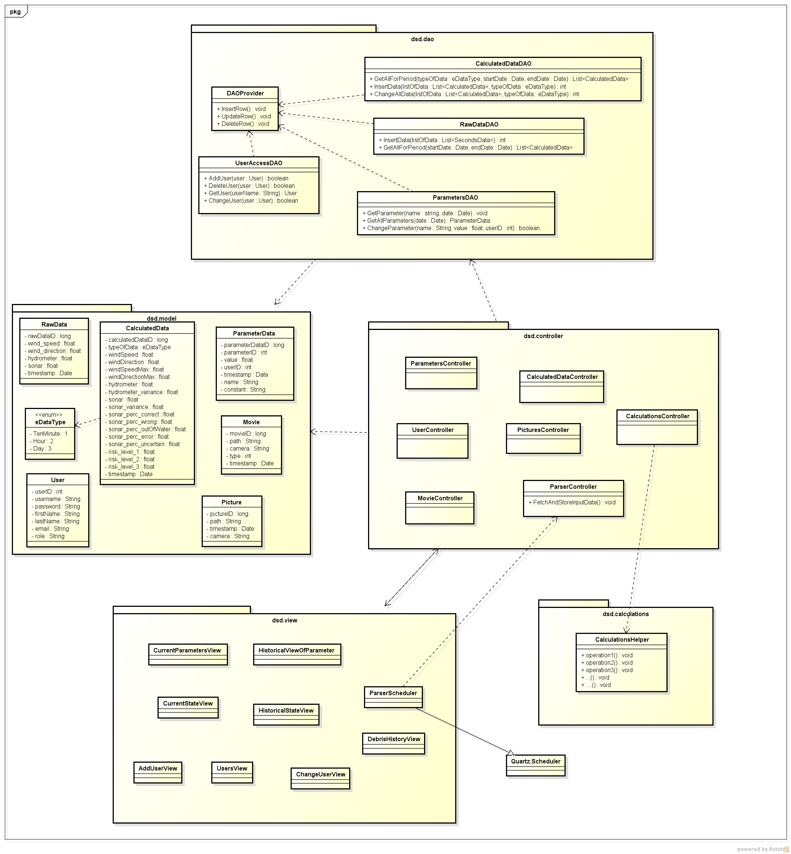

We are conforming to model – view – controller pattern. With additional layer for communicating with database called DAO. Since it is hard to plan the whole system design in advance, we were able to sketch the detail only for lower layers, since we have also the database design. When the development process will be at a further stages, we will be able to get the more detailed picture of the class diagram.
Layers description:
- DAO – layer for communicating with the database, knows about the controller and the model layer
- model – contains raw classes with their fields and properties
- controller – layer which combines all the other layer because other layers usually communicate through this layer
- view – layer that consists mainly from Servlets and .jsp pages

Deployment
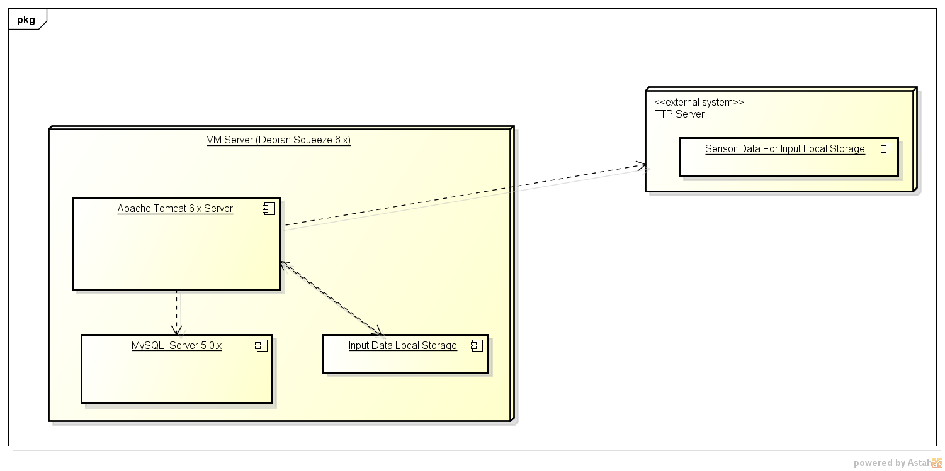
The communication with the external server that holds the input files is still subject of discussion. What we received from the customer for testing are row files from the years 2011 and 2012. Because of that and because of the fact that we are not allowed to access the real system, we don't have the possibility to test the system for a real environment use.
Regardless of this difficult constraints, we will deploy the data from the history to our server without accessing the ftp server and we will parse the data directly from our server.
Our server is a compact hardware unit consisting of 3 major components:
- MySQL database
- Apache tomcat web application server
- Input data local storage (storing the real input text files)

Class Diagrams

Package Dependencies
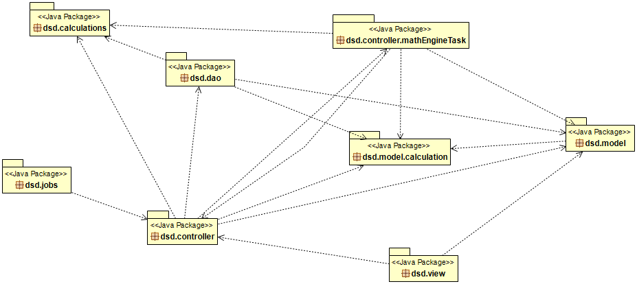
These are the dependencies between the packages in our software; we can notice that the dsd.controller is in the middle of the other packages and is used by all the other ones.
Thus, it is the main package of our product, that controls the flow of data and calculations.

DAO Package
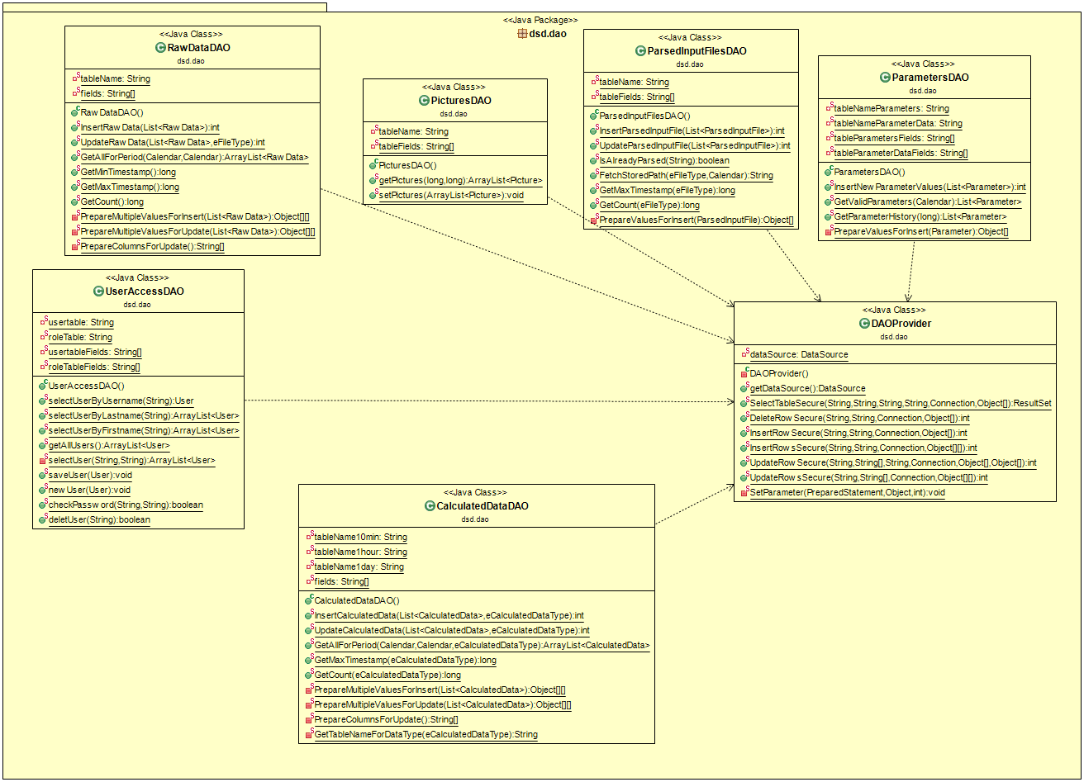

Controller Package
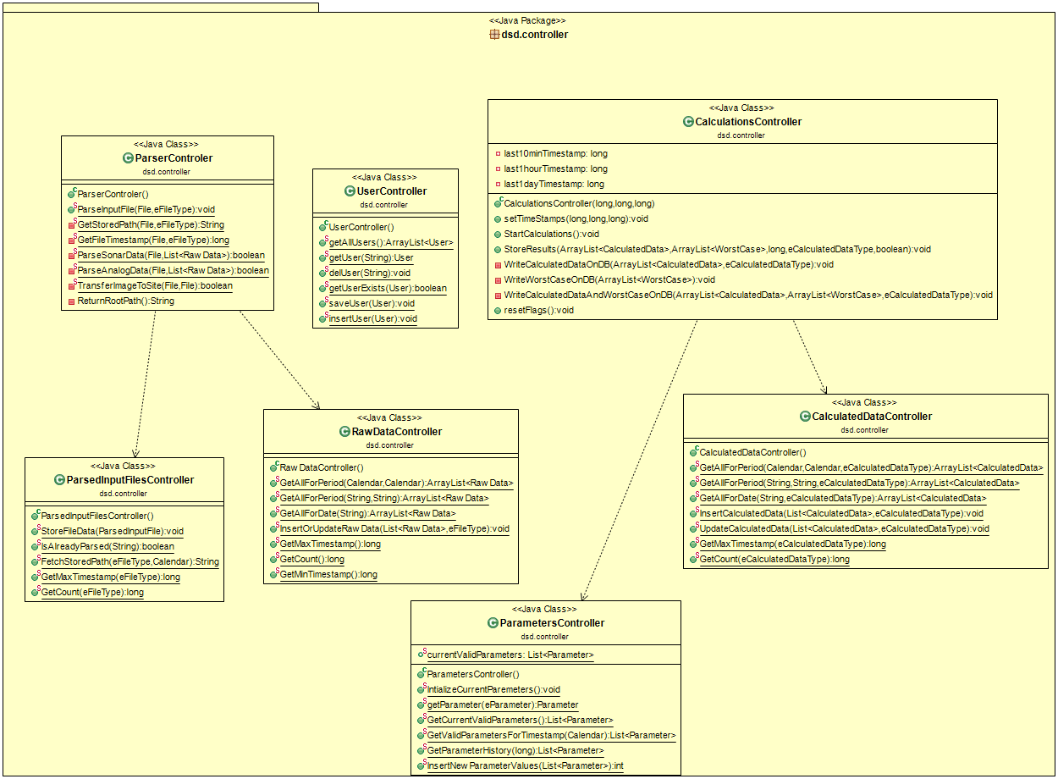

Model Package
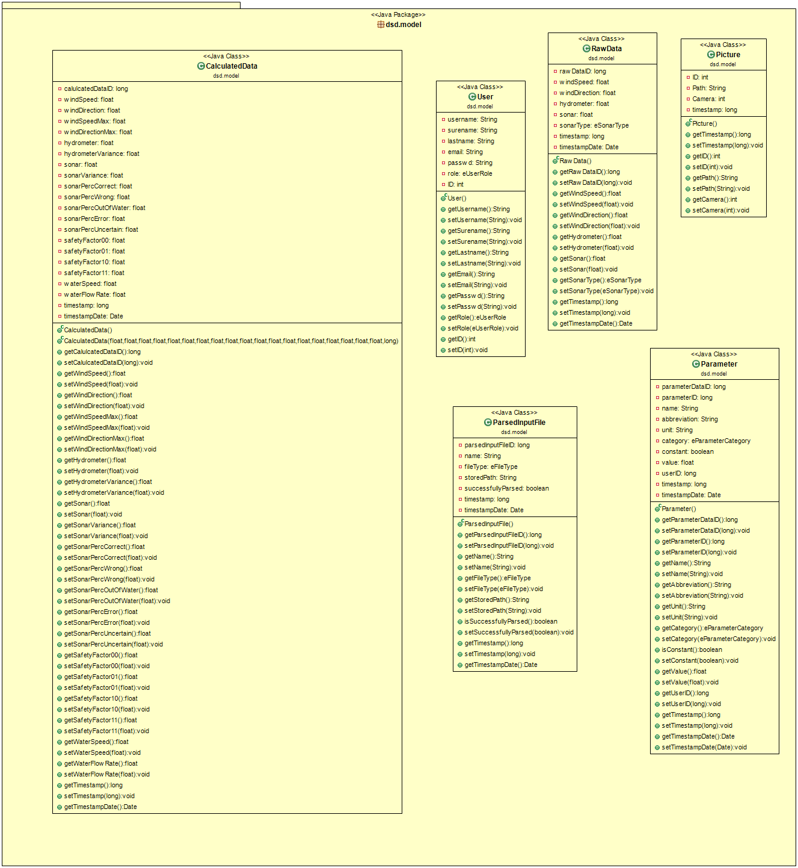

View Package
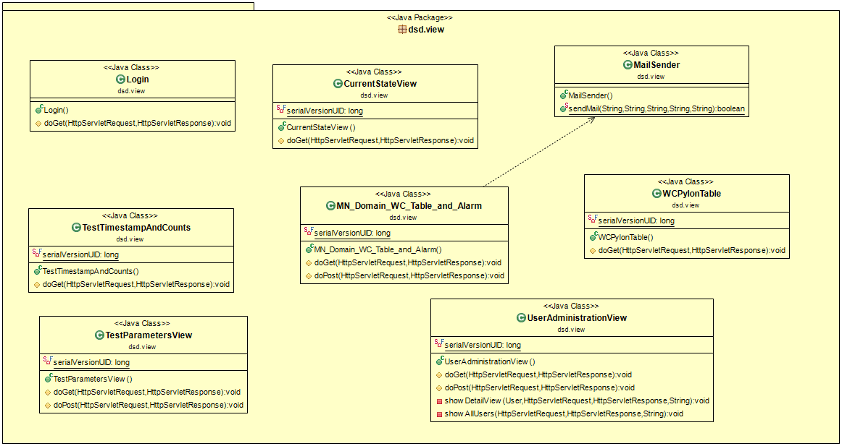

Data flow / Interactions / Dependencies

Add User
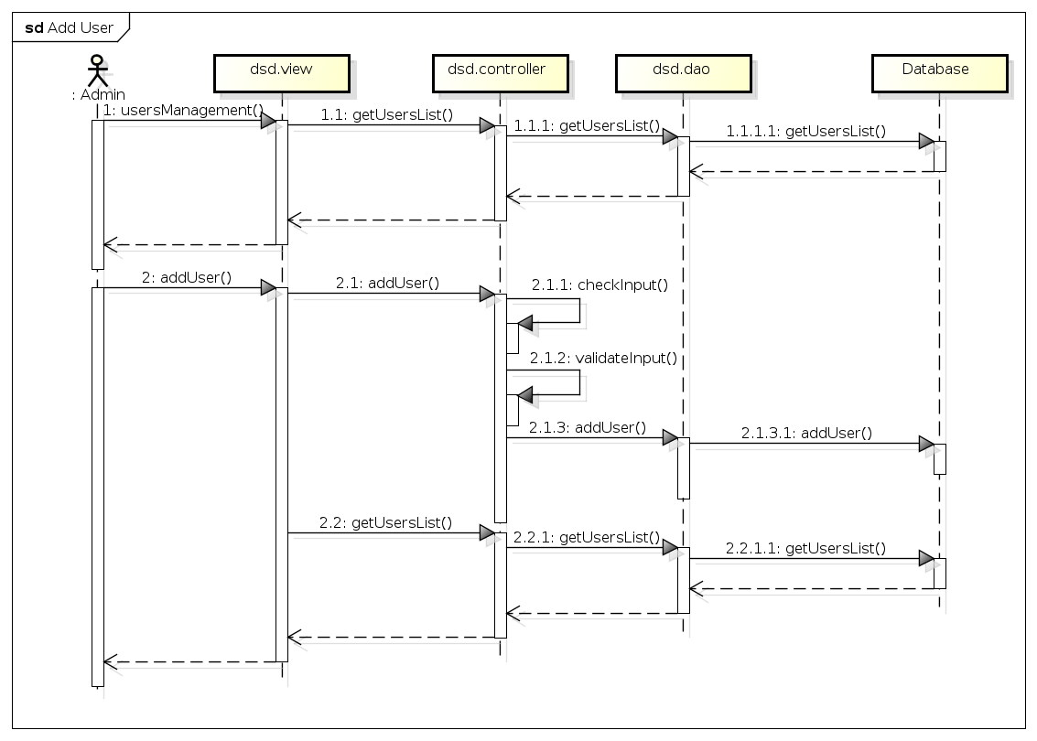
If the user wants to add a new user he go to the UserMangement. On this side he will provide Information above all user, fetching through the controlling. In this view, he can create a new users. This question will be provided by the view to the controller, who will perfom the task.

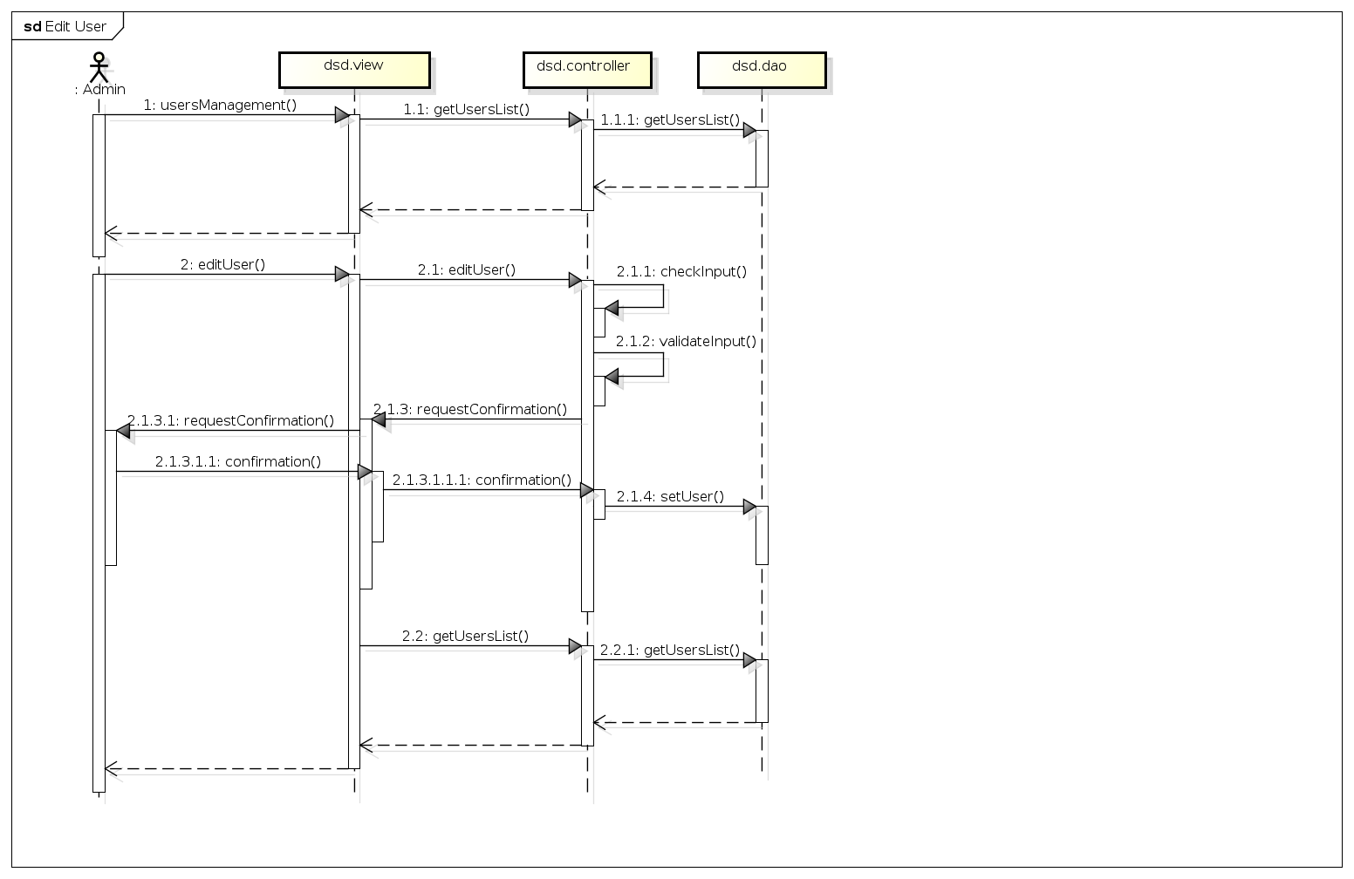
Edit User
In the UserMangementView the administrator is able to edit a user. If he edit a user, the view give the call to the controller, who will perform the task.

Log In
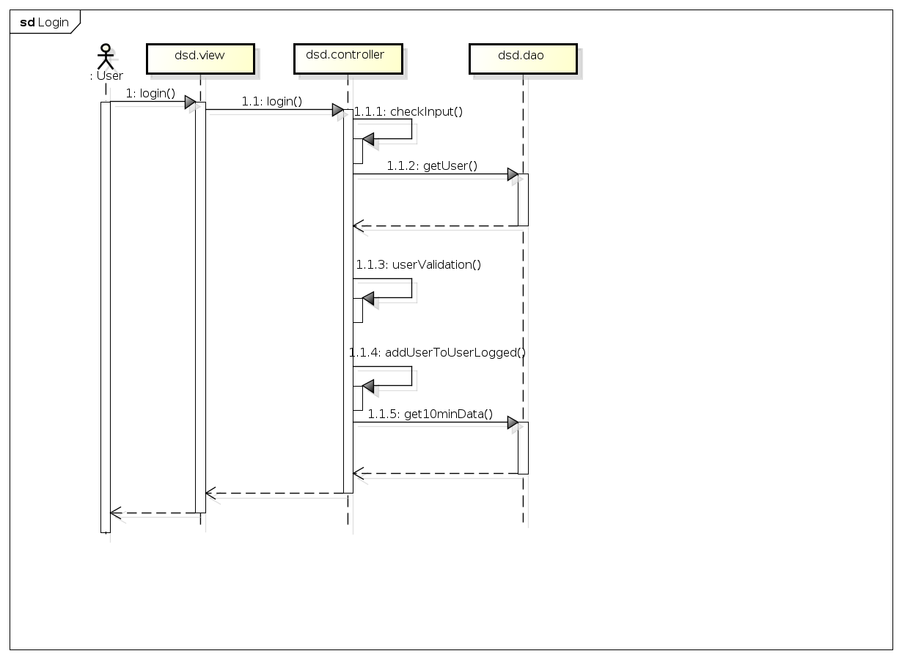
If a user logs in, the view will send the credentials to the controller, who will fetch the necessary data from the dao and check the login-request.

Log Out
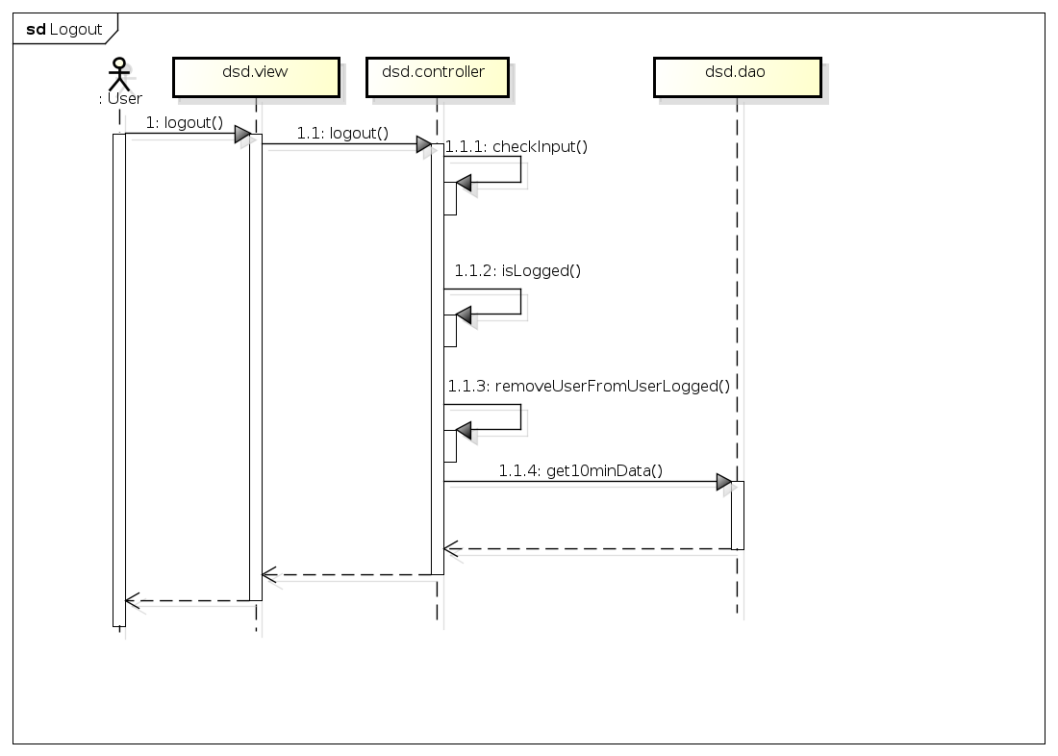
If the view gets a logout-request, he will provide the info to the controller, who performed the task.

Remove User
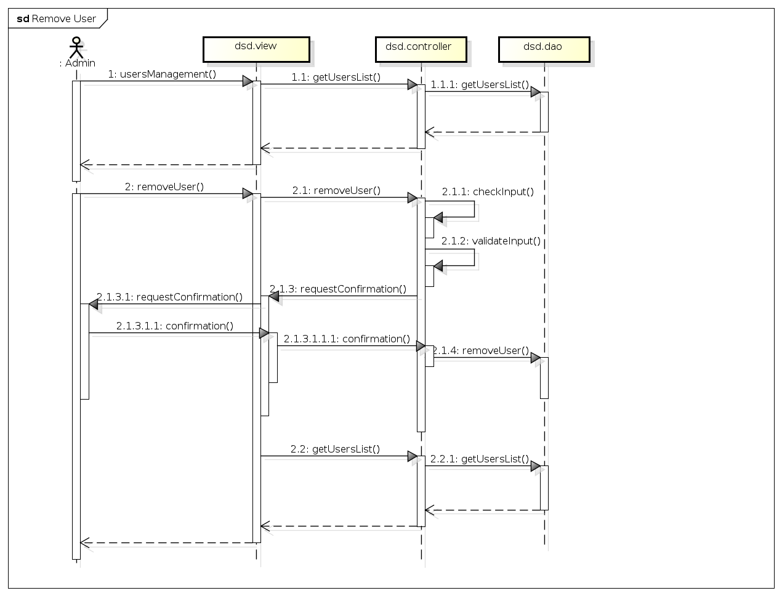
The Administrator can over the userMangementView remove a User. If the view recognize such a request, it will provide the information to the controller. The controller will perform the tasks.

Data Types / Formats
There are three kind of inputs in two kind of formats:
- analog****.txt
- sonar*****.txt
- picture****.jpg
The analog file contains:
- Wind speed (unity measure mA)
- Distance between the Hydrometer and the level of water (unity measure mA)
- Wind direction (unity measure mA)
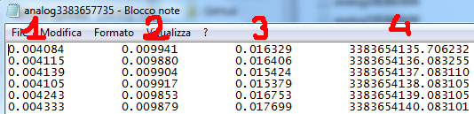
- Timestamp of the detection of the sample (LabView encode → see before)[decimals can be dropped]
The sonar file contains 2 columns of values, offset of a line (fig.5):
- Distance between the sonar and the bottom of the river (unity measure meters)
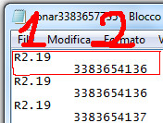
- Timestamp of the detection of the sample (Labview encode → see before)
The images are two, one for each direction (Mantova – Modena):
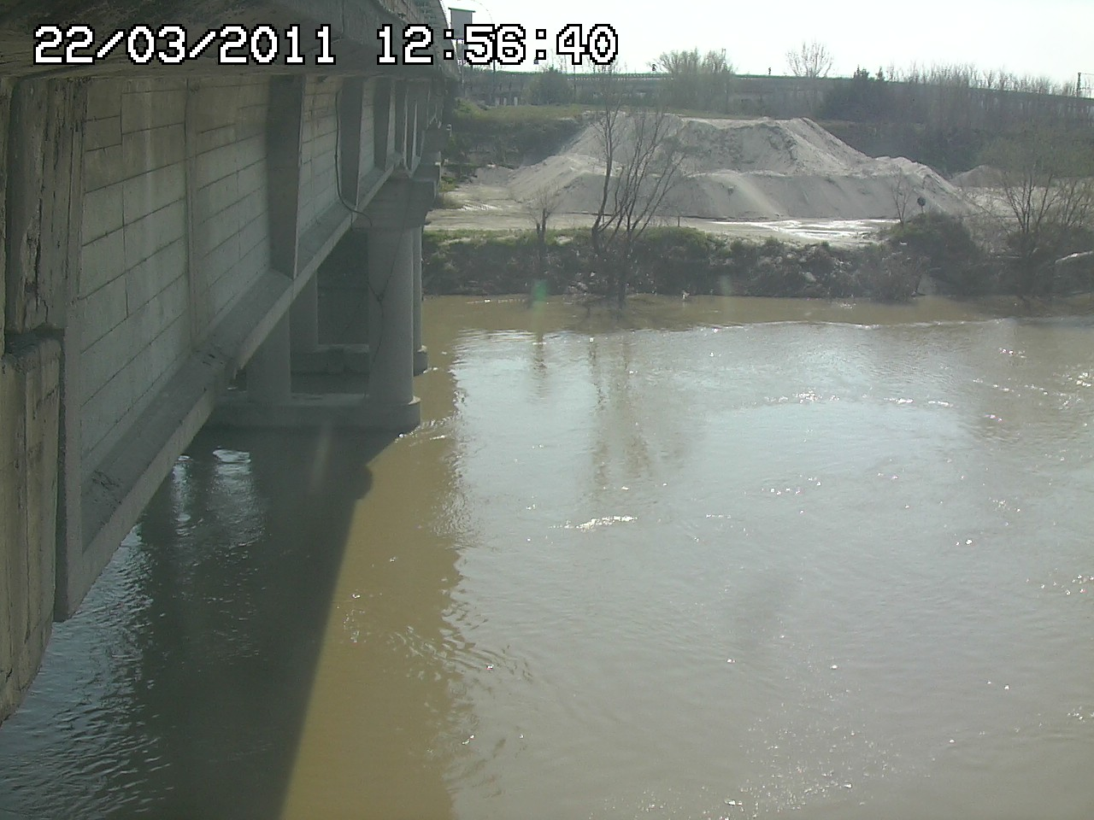
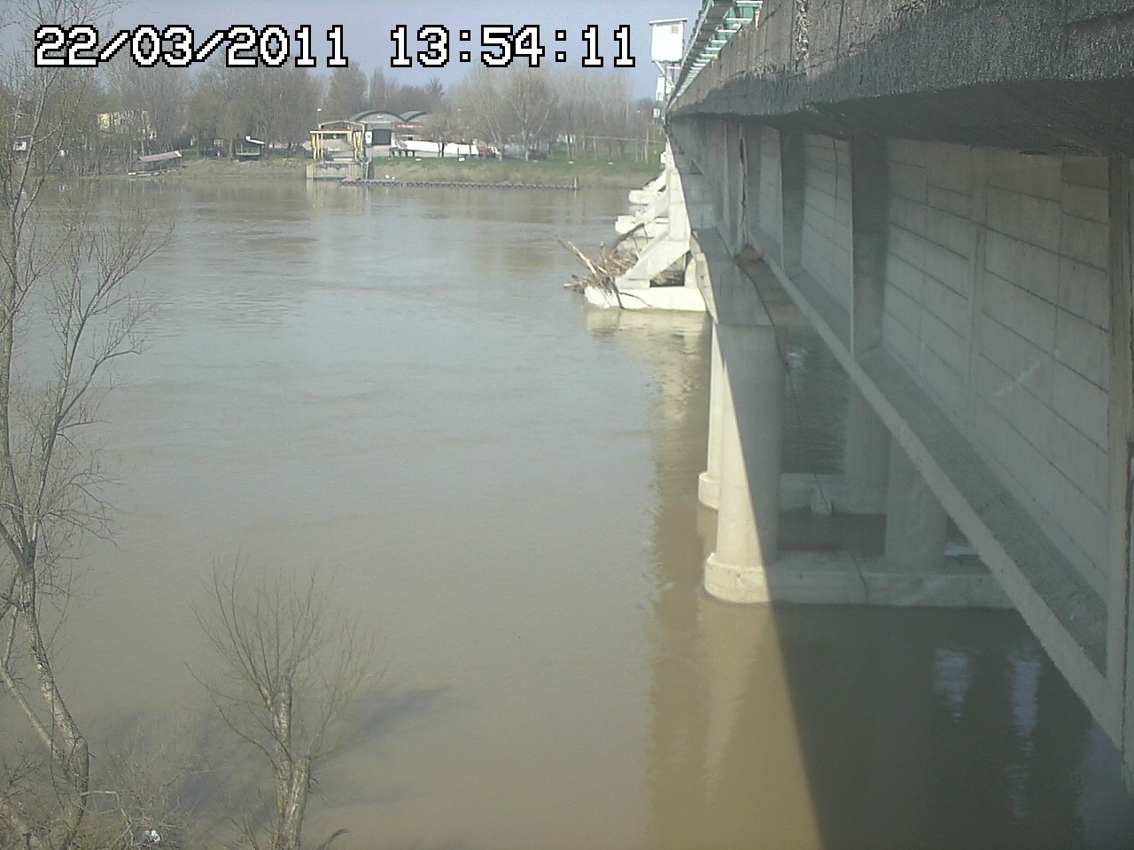
(Mantova) (Modena)

Database Model
In the Database we will two different kind of data. At the one side we have the sensor-data and calculated data and on the other side we will have administration data, like the users and their roles.

This Entity-Realtionship-Diagram shows an abstract view on the database. We will have four tables to store the raw and calculated data. Also we need one table to store meta-data like path and date of the pictures.
For administration and the website-access we need to store the users and their role. Also we need to store the parameters and their values and changes.

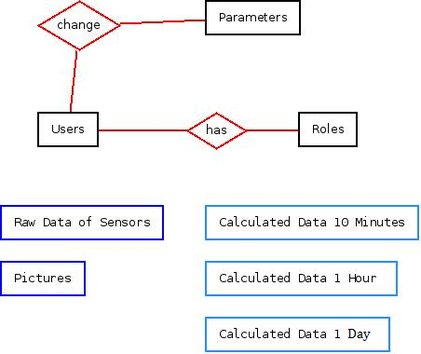Entity-Relationship-Diagram of RTBM-Database

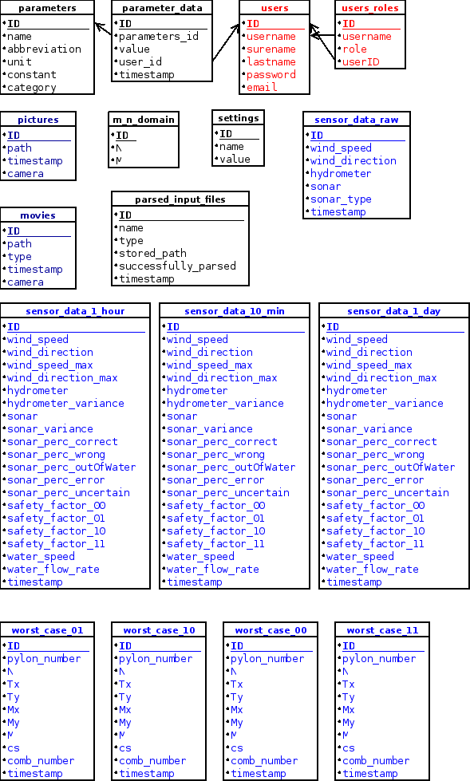

Table structure for table parameters
The table “parameters” store all available parameters of the system and the information, if this parameter is changeable by the user.
Column | Type | Null | Default
ID | int(11) | No
name | varchar(100) | No
abbreviation | varchar(30) | No
unit | varchar(20) | No
constant | tinyint(1) | No
category | int(4) | No

Table structure for table parameter_data
The table “parameter_data” stores every change of a parameter and the according timestamp and the users, who changed the parameter. So this table also contains the actual value of every parameter.
Column | Type | Null | Default | Links to
ID | int | No
parameters_id | float | No |  | parameters (ID)
value | int | No
user_id | int | No |  | users (ID)
timestamp | timestamp | No | CURRENT_TIMESTAMP

Table structure for table pictures
The table “picture” provide meta-information to every picture from the both webcames.
Column | Type | Null | Default
ID | int | No
path | varchar | No
timestamp | timestamp | No | CURRENT_TIMESTAMP
camera | int | No

Table structure for table movies
The table “movies” provide meta-information to every movie created from the pictures.
Column | Type | Null | Default
ID | int | No
path | varchar | No
type | smallint
timestamp | timestamp | No | CURRENT_TIMESTAMP
camera | tinyint | No

Table structure for table sensor_data_1_day
In the table “sensor_data_1_day” the precalculated-mean-data for every day will be stored.
Column | Type | Null | Default
ID | int(10) | No
wind_speed | float | No
wind_direction | float | No
wind_speed_max | float | No
wind_direction_max | float | No
hydrometer | float | No
hydrometer_variance | float | Yes | NULL
sonar | float | Yes | NULL
sonar_variance | float | Yes | NULL
sonar_perc_correct | float | Yes | NULL
sonar_perc_wrong | float | Yes | NULL
sonar_perc_outOfWater | float | Yes | NULL
sonar_perc_error | float | Yes | NULL
sonar_perc_uncertain | float | Yes | NULL
safety_factor_00 | float | Yes | NULL
safety_factor_01 | float | Yes | NULL
safety_factor_10 | float | Yes | NULL
safety_factor_11 | float | Yes | NULL
water_speed | float | Yes | NULL
water_flow_rate | float | Yes | NULL
timestamp | timestamp | No | CURRENT_TIMESTAMP

Table structure for table sensor_data_1_hour
In the table “sensor_data_1_hour” the precalculated-mean-data for every hour will be stored.
Column | Type | Null | Default
ID | int(10) | No
wind_speed | float | Yes | NULL
wind_direction | float | Yes | NULL
wind_speed_max | float | Yes | NULL
wind_direction_max | float | Yes | NULL
hydrometer | float | Yes | NULL
hydrometer_variance | float | Yes | NULL
sonar | float | Yes | NULL
sonar_variance | float | Yes | NULL
sonar_perc_correct | float | Yes | NULL
sonar_perc_wrong | float | Yes | NULL
sonar_perc_outOfWater | float | Yes | NULL
sonar_perc_error | float | Yes | NULL
sonar_perc_uncertain | float | Yes | NULL
safety_factor_00 | float | Yes | NULL
safety_factor_01 | float | Yes | NULL
safety_factor_10 | float | Yes | NULL
safety_factor_11 | float | Yes | NULL
water_speed | float | Yes | NULL
water_flow_rate | float | Yes | NULL
timestamp | timestamp | No | CURRENT_TIMESTAMP

Table structure for table sensor_data_10_min
In the table “sensor_data_10_min” the precalculated-mean-data for every 10 minutes will be stored.
Column | Type | Null | Default
ID | int(10) | No
wind_speed | float | No
wind_direction | float | No
wind_speed_max | float | No
wind_direction_max | float | No
hydrometer | float | No
hydrometer_variance | float | Yes | NULL
sonar | float | Yes | NULL
sonar_variance | float | Yes | NULL
sonar_perc_correct | float | Yes | NULL
sonar_perc_wrong | float | Yes | NULL
sonar_perc_outOfWater | float | Yes | NULL
sonar_perc_error | float | Yes | NULL
sonar_perc_uncertain | float | Yes | NULL
safety_factor_00 | float | Yes | NULL
safety_factor_01 | float | Yes | NULL
safety_factor_10 | float | Yes | NULL
safety_factor_11 | float | Yes | NULL
water_speed | float | Yes | NULL
water_flow_rate | float | Yes | NULL
timestamp | timestamp | No | CURRENT_TIMESTAMP

Table structure for table sensor_data_raw
The table “sensor_data_raw” contains all raw data.
Column | Type | Null | Default
ID | int | No
wind_speed | float | No
wind_direction | float | No
hydrometer | float | No
sonar | float | No
sonar_type | int | No
timestamp | timestamp | No | CURRENT_TIMESTAMP

Table structure for table users
The table “users” contains all users and the according to information.
Column | Type | Null | Default
ID | int | No
username | varchar | No
surename | varchar | Yes | NULL
lastname | varchar | Yes | NULL
password | varchar | No
email | varchar | Yes | NULL

Table structure for table users_roles
The table “users_roles” contain the relationship between users and roles.
Column | Type | Null | Default | Links to
ID | int | No
username | varchar | No |  | users (username)
role | varchar | No
userID | int | No |  | users (ID)

Table structure for table m_n_domain

Column | Type | Null | Default | Links to
ID | int | No
user | int | No |  | users (ID)
role | int | No |  | roles (ID)

Table structure for table worst_case_00

Column | Type | Null | Default
ID | int(10) | No
pylon_number | int(11) | No
N | float | No
Tx | float | No
Ty | float | No
Mx | float | No
My | float | No
M | float | No
cs | float | No
comb_number | int(11) | Yes | NULL
timestamp | timestamp | No | CURRENT_TIMESTAMP

Table structure for table worst_case_01

Column | Type | Null | Default
ID | int(10) | No
pylon_number | int(11) | No
N | float | No
Tx | float | No
Ty | float | No
Mx | float | No
My | float | No
M | float | No
cs | float | No
comb_number | int(11) | Yes | NULL
timestamp | timestamp | No | CURRENT_TIMESTAMP

Table structure for table worst_case_10

Column | Type | Null | Default
ID | int(10) | No
pylon_number | int(11) | No
N | float | No
Tx | float | No
Ty | float | No
Mx | float | No
My | float | No
M | float | No
cs | float | No
comb_number | int(11) | Yes | NULL
timestamp | timestamp | No | CURRENT_TIMESTAMP

Table structure for table worst_case_11
Column | Type | Null | Default
ID | int(10) | No
pylon_number | int(11) | No
N | float | No
Tx | float | No
Ty | float | No
Mx | float | No
My | float | No
M | float | No
cs | float | No
comb_number | int(11) | Yes | NULL
timestamp | timestamp | No | CURRENT_TIMESTAMP

Table structure for table parsed_input_files
Column | Type | Null | Default
ID | int(11) | No
name | varchar(100) | No
type | tinyint(4) | No
stored_path | varchar(200) | No
successfully_parsed | tinyint(1) | No
timestamp | timestamp | No | CURRENT_TIMESTAMP
Column | Type | Null | Default

Table structure for table settings
Column | Type | Null | Default
ID | int(11) | No
name | varchar(100) | No
value | varchar(100) | No

Used Libraries to Excess-Database
Since our program only communicate over Java with the MySQL server, we can use JDBC for every communication with the Database.

Security
For security reason we use an own user for access to database. This user has only access to the RTMS-DB and can only create local connections to database.

Web site organization

Web site organization
We are following the usual tomcat web application organization expanded with other components needed for our web application.
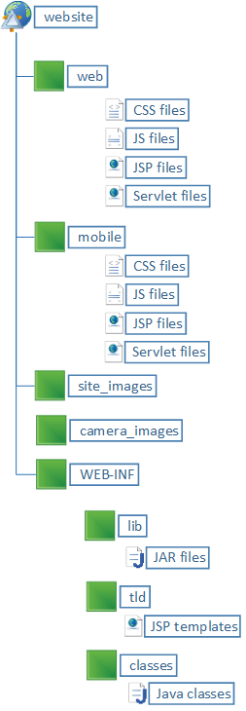  Website Folder | Files included
web | All the style sheet files, .jsp files, html files, javascript files, etc.
mobile | The web application of the project
site_images | Static images used for the page design
WEB-INF/lib | Other external java libraries needed for our project
WEB-INF/tld | Folder for storing the templates
WEB-INF/classes | Folder where our classes and our java code goes

